# CS 255 System Design Document Template

Ryan Zackus

12/9/2023

## UML Diagrams

### UML Use Case Diagram

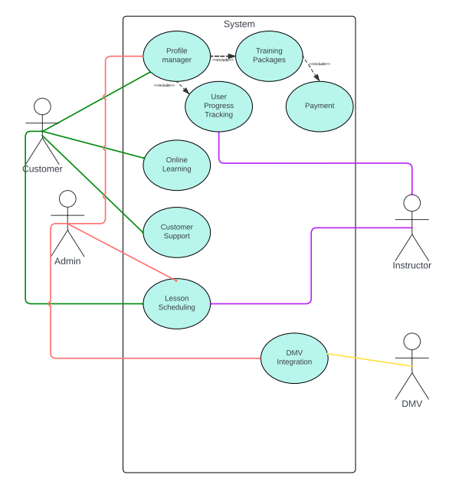

### UML Activity Diagrams

### UML Sequence Diagram

### UML Class Diagram

## Technical Requirements

On a technical level this system will have to have an easily scalable server host, capable of hosting this system without limiting the performance. The front end will be created to cater to users on all types of operating systems. That will require testing on Mac, Windows, and mobile devices. On top of that, the use of an authentication method using a cloud-based server would be best. This way the system can also be backed up consistently in case of any issues. A good internet connection is a must for a web-based application to stay available to users. Using industry best practices, we will create a framework that is secure, maintainable, and high performance.